Memory Based Products

1. RAM- DRAM, SRAM
2. ROM- HDD,SSD
3. RAM:

RAM is short for “random access memory’, RAM is one of the most fundamental elements of computing. RAM is the super-fast and temporary data storage space that a computer needs to access right now or in the next few moments.

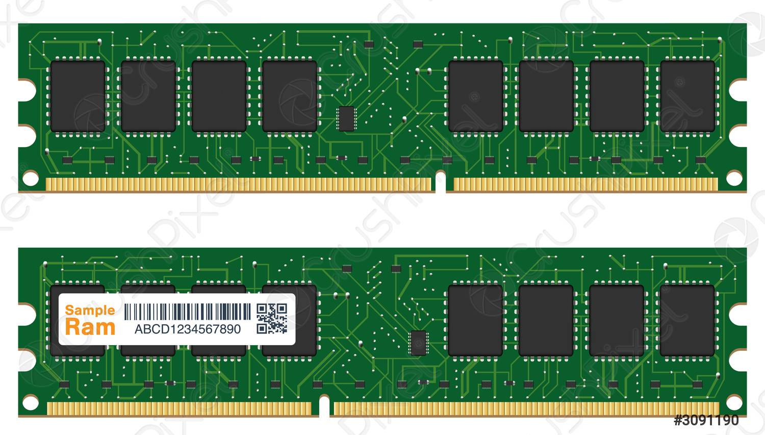

1. DRAM:

Dynamic random-access memory is a type of random-access semiconductor memory that stores each bit of data in a memory cell, usually consisting of a tiny capacitor and a transistor, both typically based on metal-oxide-semiconductor technology.

1. SRAM:

Static random-access memory is a type of random-access memory that uses latching circuitry to store each bit. SRAM is volatile memory data is lost when power is removed. The term 'static' differentiates SRAM from DRAM which must be periodically refreshed.

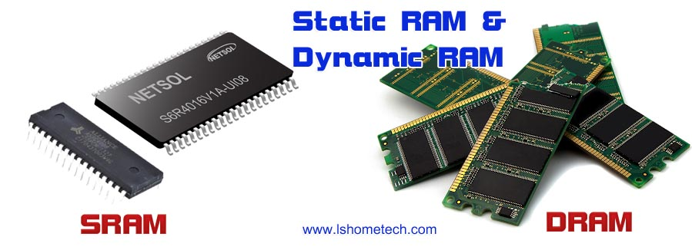

1. ROM:

Read-only memory is a type of non-volatile memory used in computers and other electronic devices. Data stored in ROM cannot be electronically modified after the manufacture of the memory device.

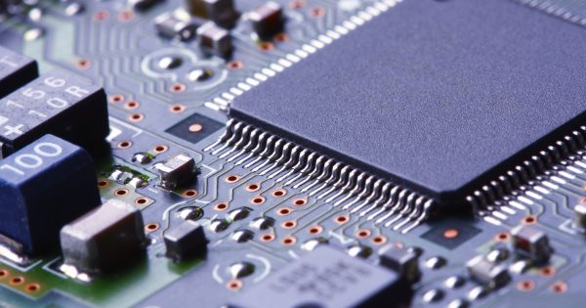

1. HDD:

An HDD is a data storage device that lives inside the computer. It has spinning disks inside where data is stored magnetically. The HDD has an arm with several "heads" (transducers) that read and write data on the disk.

1. SDD:

A solid-state drive (SSD) is a new generation of storage device used in computers. SSDs use flash-based memory, which is much faster than a traditional mechanical hard disk. Upgrading to an SSD is one of the best ways to speed up your computer.

